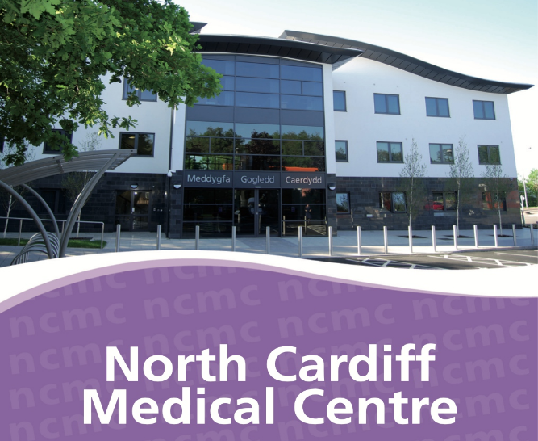
North Cardiff Medical Centre operates a mix of ‘book on the day’ appointments as well as booking 1 week in advance for GP appointments. Lines open at 8am Monday to Friday. You will be asked the nature of the problem to enable the team to book you the most suitable appointment, this can include a Doctor, an Advanced Nurse Practitioner, Physiotherapist or Urgent Primary Care Centre.
North Cardiff Medical Centre
Excalibur Drive
Thornhill
CF14 9BB

Telephone: 02920 764444
Website: www.northcardiffmedicalcentre.co.uk
Facebook : https://www.facebook.com/northcardiffmedicalcentre
If you are suffering with an eye problem, you will be asked to contact an optician.
If you are suffering with a dental problem, you will be asked to contact a dentist.
If you are suffering with a common ailment, you will be asked to contact a local pharmacy.

Find out what services are available near you by visiting: https://111.wales.nhs.uk/localservices

Nurse appointments at the practice can be booked up to 4 weeks in advance for things like asthma/COPD reviews, diabetic reviews, cervical smears, blood pressure checks and depo injections.

For minor injuries or if you need to visit the A&E department please call NHS 111 before attending. If you require urgent medical attention outside of normal surgery hours (or on weekends/bank holidays). In a genuine emergency, you should call 999.

New patient protocol and questionnaire – 16+
All new patients joined this Practice are requested to present in person and to provide proof of residency within the Practice boundary.
In order to provide you with good medical care, please complete the following questionnaire as accurately as you can, as the information will be added to your medical record.
ALL OF YOUR INFORMATION WILL BE KEPT COMPLETELY CONFIDENTIAL

Are you on any repeat medication?
Prior to joining the Practice, please ensure you have 1 month supply of medication from your previous GP surgery.

Yes No

If you are on repeat medication please supply the Practice with a copy of your repeat slip, which can be obtained from your previous surgery. If you do not provide the Practice with a copy, there may be a delay in your medications being issued.
Personal details
Title
Surname
Forenames
Date of birth
Address & postcode
Mobile number
Home number
Email

Do you consent to the Practice contacting you by text message or email for appointment reminders, prescription and sick note updates or anything relevant to your healthcare?
Yes No

Are any members of your household registered at the Practice?
Name | DOB | Relationship to you

Next of kin details:
Full name | Contact number

Have you ever served in the British Armed Forces?
Yes No
Does a member of your family currently serve in the British Armed Forces?
Yes No

Are you a Carer? Yes No

If yes, is the person you care for a patient with this Practice? Yes No

If yes, please provide their name and date of birth:

Doe someone care for you? Yes No

Please tick if you are:
Blind Deaf
Partially sighted Hearing impaired

What is your ethnic origin? Please tick
British or Mixed British |  | Indian
African |  | Japanese
Caribbean |  | Pakistani
Chinese |  | Other ethnic group
European |  | I do not wish to give this information

What is your first language?

Do you need an interpreter? Yes No

If yes, which language?

More about you
Have you previously been registered at North Cardiff Medical Centre?
Yes No

Height:
Weight:

Smoking Status
Have you ever smoked? Yes No
If yes, do you still smoke? Yes No
How many per day?

If you are an ex-smoker, when did you give up?

Alcohol Consumption
1 unit of alcohol is 1/2 pint of beer, 1 glass wine or 1 pub measure of spirits.

Looking at an average day, how much alcohol do you drink?
□ Teetotaller □ 1-2 units a day □ 7-9 units a day
□ Rarely □ 3-6 units a day □ +9 units

Exercise
How much exercise do you take?
□ None □ Light □ Moderate □ Vigorous

North Cardiff Medical Centre
Acceptable Behaviour Contract
An Acceptable Behaviour Contract is a signed written agreement between the patient and a GP Practice to make explicit that the patient will conduct themselves in an appropriate and respectful manner to all staff.
Patient Name: DOB:

By registering with the Practice I, (the patient) agree the following:
- I agree to refrain from using abusive or offensive language, making threats of violence or aggressive behaviour; in person, on the phone, in writing or on social media.
- I will treat all NHS staff, fellow patients, carers and visitors politely and with respect at all times.
- I will not consume alcohol, smoke or take any form of non-prescribed medication or drugs whilst on the surgery premises.
- I accept and understand that the Practice is obliged to provide a safe and secure environment for its staff and to care for their health and safety.

By breaching this contract, I can expect to be:
- Removed from the Practice list
- Reported to the police with a view to charges being brought against me.
- Considered by the Health Board for referral to the Alternative Treatment Scheme.

I confirm that I have read the above Practice Protocol and understand the information presented. I confirm that I have read and understand the meaning of the Acceptable Behaviour Contract and understand the consequences of breaking the contract.

Signed (the patient): Date:

North Cardiff Medical Centre
Eligibility form

I am a permanent resident in the UK (Wales)

I am an ordinary resident in the UK (Wales) for a settled purpose (work, study) for at least six months.

I have formally applied for asylum in the UK and my application is still under consideration by the Home Office.

I am a refugee who has been give leave to remain in the UK.

I am applying for registration as a patient at the Practice and I declare my eligibility as identified above. I understand that if my declaration is later found to be false, I may forfeit my right to treatment at the Practice and may be liable for cost of treatment.

Signed (Patient or if child – signature of parent/guardian)

Date: .

MEDDYGFA GOGLEDD THE NORTH CARDIFF
CAERDYDD MEDICAL CENTRE
Excalibur Drive Excalibur Drive
Thornhill Thornhill
Cardiff Cardiff
CF14 9BB CF14 9BB
Ffon (029) 2076 4444 Phone (029) 2076 4444
Ffacs (029) 2074 1889 Fax (029) 2074 1889

Dr Richard G H Jones, Dr Helen Sherwood, Dr Jonathon L R Campbell,
Dr Huw Lloyd-Morgan, Dr Elise Lang, Dr Roya Basir, Dr Charlotte Wilson

Website: www.northcardiffmedicalcentre.com
MHOL Registration form

My Health Online is a new online service brought to you from NHS Wales. My Health Online offers patients the convenience to book appointments and request repeat prescriptions using the internet.

If you are over 16 and wish to register to use My Health Online, please fill in the boxes below.
PLEASE NOTE – Multiple patients cannot be linked to one email account. Each patient is required to have their own email address.

Please set up a My Health Online Account and issue me with a letter containing my account details.
Full Name
Date of Birth
Address

Phone Number |  | Email :
Signature |  | Date:

The following sections to be completed by practice staff.
Practice Checklist
The following checks should be completed before a patient can receive access to My Health Online.
- Patient’s identity verified by document (drivers licence/passport)
Details of documents checked and added to the GP system
- Patient’s name and date of birth checked on this form and updated on the clinical system. (if necessary)
- Registration process and next steps to registration explained
- Patient Guide and Frequently Asked Questions provided to patient
- Advise patients to register their online account over the next 24 – 48 hours

